**Smart SDLC – AI Enhanced Software Development Lifecycle**

|  |  |
| --- | --- |
| Date | 31 January 2025 |
| Team ID | LTVIP2025TMID32163 |
| Project Name | Smart SDLC – AI Enhanced Software Development Lifecycle |
| Maximum Marks | 4 Marks |

**Prioritization Template:**

Smart SDLC is a generative AI-powered application developed using Fast-API and IBM's Granite-3.3-2b-instruct model. It provides phase-wise assistance across the Software Development Life-cycle (SDLC), enabling developers and learners to understand and implement software engineering practices through intelligent automation.

Reference: <https://www.mural.co/templates/brainstorm-and-idea-prioritization>

**Step-1: Team Gathering, Collaboration and Select the Problem Statement**

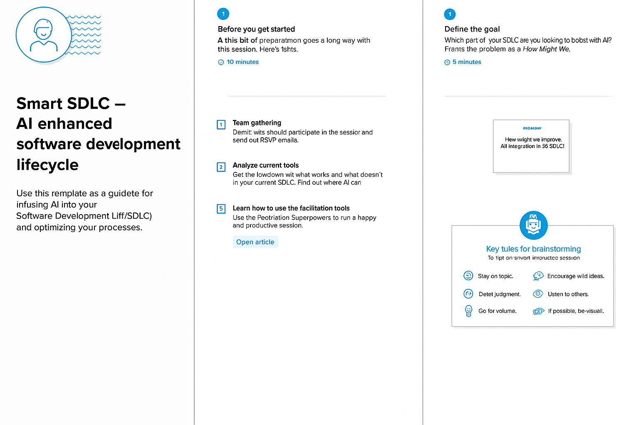

**Step-2: Idea Listing and Grouping**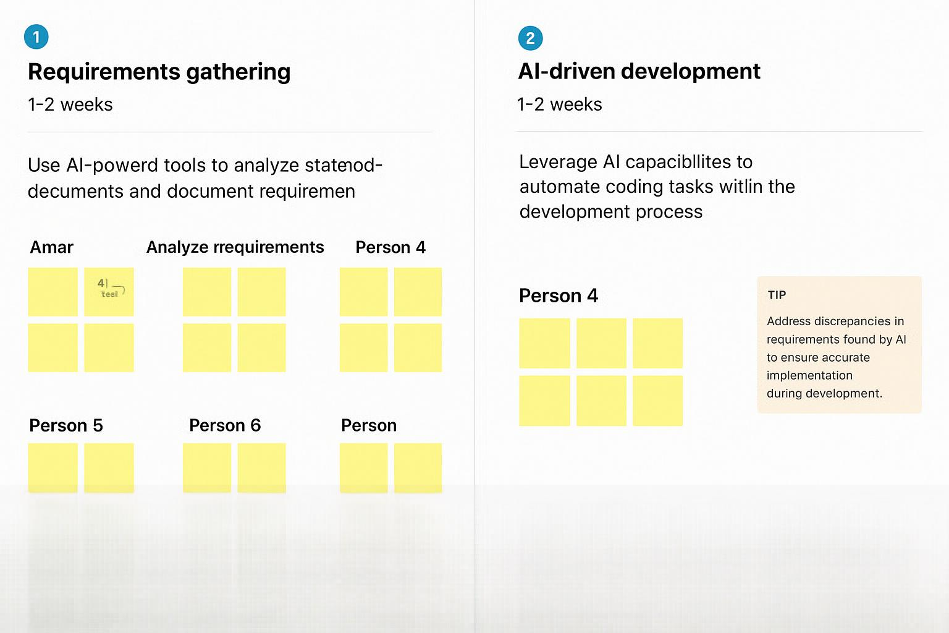

**Step-3: Idea Prioritization**

